Project 3, BIOS 6623

Trajectories of Onset of Memory and Other Cognitive Loss

Rachel Johnson

27 November 2017

**Introduction**

The goal of this project is to identify trajectories of onset of memory and other cognitive onset loss in a population of healthy, community dwelling, and cognitively intact elders at risk of developing mild cognitive impairment (MCI) or dementia. 216 individuals entered the study, and 187 of these were included in the descriptive statistics and analysis because they had at least three measurements of the outcome of interest over the course of the study. This cognitive test of interest that was measured over time in these individuals was category fluency for animals. We were interested in determining the rate of memory decline in healthy individuals over the course of the aging process, as well as the rate of memory decline in those individuals who would be diagnosed with MCI or dementia during the course of the study. Finally, we wanted to determine the period of time before MCI or dementia diagnosis in which the rate of memory decline either changes or accelerates.

**Methods**

There were 216 individuals included at the start of the study. Only those with at least three outcomes measurements for animal category fluency were included in the analytic cohort, so 29 individuals were removed from the data set and 187 remained. The baseline demographic information at baseline for this population is reported in Table 1, with counts and percentages reported for categorical variables and means and standard deviations reported for continuous variables. The baseline values for other cognitive tests are also noted, to provide allow for a more detailed comparison of the groups where individuals were and were not diagnosed with dementia during the study.

To prepare for interpretation of the models that were to be run, new variables were created. First, a new age variable was create in which the minimum age in the study, 59, was subtracted from all other ages to make the intercept more interpretable in the models. Second, a variable was created to show the difference between age at an observation and age at dementia/MCI diagnosis, which was used to plot the animal category fluency score in time leading up to diagnosis.

The time-before-diagnosis variable was also used in finding the change-point for the model—the point in time before diagnosis at which memory/cognitive scores begin to decline or change at a different pace. A model was to be fit that accounted for individuals’ age, dementia status at the end of the study, socioeconomic status as measured by the Hollingshead scale, and gender in explaining their animals category fluency score, as well as including a term that would allow linear trends to change at some point prior to diagnosis.

To be able to allow these terms to change, a change-point was determined for this model through likelihood-based methods. Maximum likelihood methods with Gaussian assumptions fit a variety of change points that ranged from 6 years before diagnosis to 2 years after diagnosis. From this analysis, a change point was determined, and a final variable was created which selected the maximum of the age of onset subtracted from the age of the individual minus the change point.

To determine a confidence interval for the change point, 1000 iterations of a bootstrap were run that sampled with replacement from the 187 individuals in the analysis cohort, calculated the change point based on this new data set, and estimated the slope before and after the change point. The change-point 95% confidence interval was calculated by selecting the 2.5th and 97.5th percentiles of the bootstrap means.

Once the change point was determined, a linear mixed model was fit, and three structures that accounted for the repeated measures on subjects over time were tested. First, a model with a random intercept only was fitted. Second, a model with a random intercept and an AR(1) structure for the errors was fitted, and third, a model with a random intercept and a spatial power structure was fitted. The model that fit the data best was selected by choosing the model among these three fits with the lowest AIC.

**SOMETHING W/ CONDITIONAL VARIANCES TO CHANGE STANDARD ERRORS**

**Results**

The baseline demographics for the 187 individuals included in the study are displayed in Table 1. Overall, individuals entered the study at a mean age of 80.10, and were followed for an average of approximately 17.5 visits in which the category fluency score for animals was measured over the next 8.82 years. There were more women included in the study, but a much lower proportion of women were diagnosed with dementia over the course of the study. Socioeconomic scores were fairly evenly distributed between those who were and were not diagnosed with dementia/MCI in the study. Those who were diagnosed with dementia entered the study, on average, 8 years older than those were not diagnosed, and they had lower average baseline scores in all four memory and cognitive tests that were measured at their visits, including animal category fluency.

**Table 1.** This table displays the baseline demographic information of the 187 individuals who had at least 3 measurements on the animal category fluency outcome over the course of the study.

|  |  |  |  |  |
| --- | --- | --- | --- | --- |
|  |  | **Overall** | **Did not develop dementia/MCI during study** | **Developed dementia/MCI during study** |
| **n** |  | 187 | 119 | 68 |
| **Number observations (mean (sd))** | | 17.49 (7.48) | 16.42 (8.22) | 19.35 (5.54) |
| **Years of follow-up (mean (sd))** | | 8.82 (4.05) | 8.23 (4.41) | 9.87 (3.08) |
| **Gender (%)** | Male | 82 (43.9) | 59 (49.6) | 23 (33.8) |
|  | Female | 105 (56.1) | 60 (50.4) | 45 (66.2) |
| **SES (mean (sd))** |  | 49.32 (11.68) | 49.66 (10.86) | 48.74 (13.07) |
| **Age (mean (sd))** |  | 80.10 (8.87) | 77.16 (8.92) | 85.24 (6.01) |
| **BlockR (mean (sd))** |  | 24.56 (9.36) | 26.52 (9.43) | 21.12 (8.22) |
| **Animals (mean (sd))** |  | 17.33 (5.11) | 18.30 (4.99) | 15.62 (4.91) |
| **LogMemI (mean (sd))** |  | 13.48 (4.36) | 14.60 (4.02) | 11.53 (4.28) |
| **LogMemII (mean (sd))** |  | 11.13 (5.00) | 12.55 (4.51) | 8.65 (4.88) |

**Figure 1.**

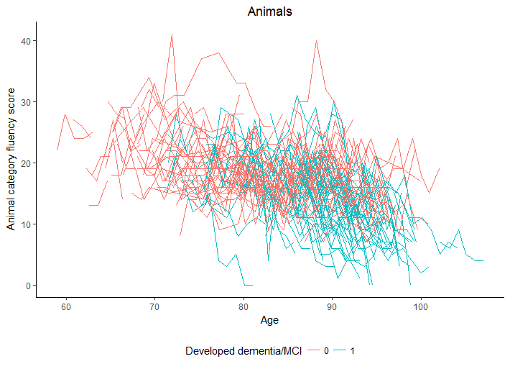

**Figure 2.**

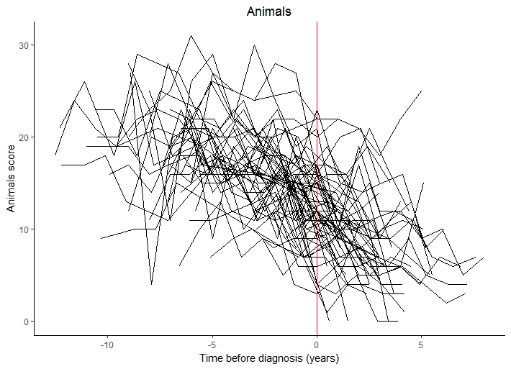

| **Modeling Animals Category Fluency Score** | | | | |
| --- | --- | --- | --- | --- |
| **Effect** | **Level** | **Estimate** | **Standard Error** | **Pr > |t|** |
| **Intercept** |  | 19.6431 | 2.2778 | <.0001 |
| **Age - 59** |  | -0.1773 | 0.07184 | 0.0137 |
| **Dementia** | **0 = undiagnosed** | 4.3903 | 2.3701 | 0.0642 |
| **(Age – 59) * Dementia** | **0 =undiagnosed** | -0.00550 | 0.07679 | 0.9429 |
| **Change-point** |  | -0.9284 | 0.1086 | <.0001 |
| **SES** |  | 0.03926 | 0.02329 | 0.0921 |
| **Gender** | **1 = male** | 0.5579 | 0.5532 | 0.3134 |

* Results: Present results for analyses described in the methods (~1-1.5 pages). Use Tables and Figures as appropriate, including in the text the full interpretation of statistical results for the main findings (i.e. point estimates, confidence bounds, p-values, interpretation of results of test).
* Conclusions: Interpret your results (~.5 to 1 page) in context of scientific question(s). Also discuss any limitations to your analysis that may affect interpretation or that require additional consideration by the investigator.

**Conclusions**

**Code**

The code for this project can be found at <https://github.com/BIOS6623-UCD/bios6623-johnsra3/tree/master/Project3/Code>.